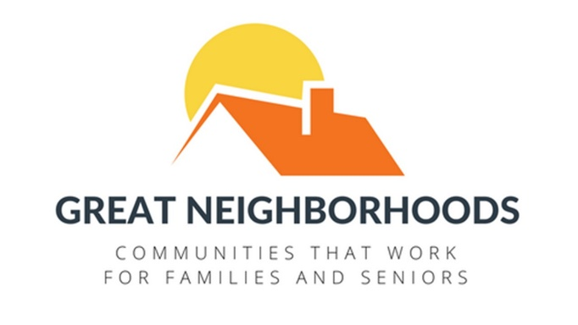
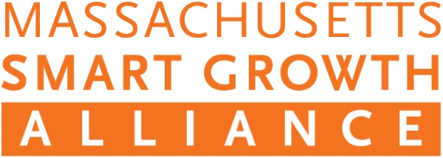

January 23, 2018
Media Contacts:

Suzanne Morse
(617) 646-1020
smorse@oneillandassoc.com

André Leroux, Executive Director, MSGA
(617) 251-3861
andre@ma-smartgrowth.org

Statement by Andre Leroux, Executive Director of the Massachusetts Smart Growth Alliance (MSGA), Regarding Governor Baker’s Housing Choice bill
“The Massachusetts Smart Growth Alliance applauds Governor Baker and his administration for recognizing the need for more housing and for launching the Housing Choice program. But on the legislative side, this bill is a first step and not a solution.
The last time that Massachusetts reformed its zoning laws was in 1975 – and it’s clear that the time has come to modernize them. Some of the areas ripe for reform include project permitting, subdivisions, board training, municipal plans, frivolous appeals, and housing discrimination. The Housing Choice bill does not address any of these deficiencies.
Right now, only 10 cities and towns out of 351 build nearly two-thirds of all the apartments in the state. We have a responsibility to address housing injustice and affordability statewide, not just in a few welcoming communities. Our young people and seniors can no longer afford to stay in the places where they have lived most of their lives.
We need more homes at the same time that we need to curb the sprawl growth that makes our communities uglier, more unequal, and costs our cities and towns money. We can achieve this by making our downtowns, Main Streets, and rural villages more development-friendly and prosperous.
Our Great Neighborhoods bills (H2420 and S81) and Chairman Honan’s housing production bill (H3845) include many important reforms that help accomplish these goals. These bills need to be considered as part of any housing and zoning package that moves through the Legislature.
So while we endorse the Governor’s modest proposal with technical improvements, we fully support the efforts of the House working group on housing and zoning to put together a more comprehensive and balanced solution. We look forward to collaborating with the Legislature and Governor Baker to complete the important work of building the homes and communities that our state needs to thrive.”

About the Massachusetts Smart Growth Alliance
The Massachusetts Smart Growth Alliance promotes healthy and diverse communities, protects critical environmental resources and working landscapes, advocates for housing and transportation choices, and supports equitable community development and reinvestment.

