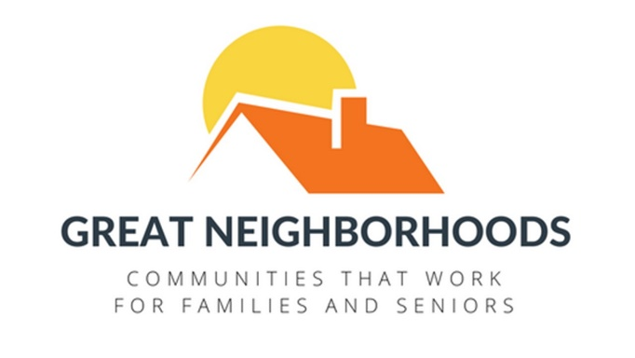
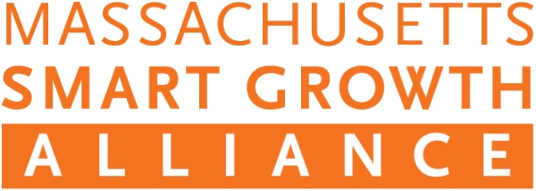

Media Contacts:
Suzanne Morse
(617) 646-1020
smorse@oneillandassoc.com

André Leroux, Executive Director, MSGA
(617) 251-3861
andre@ma-smartgrowth.org

Governor Baker Launches Housing Choice Program;
Key Victory for Great Neighborhoods Campaign

Dec. 11, BOSTON – The Great Neighborhoods campaign, led by the Massachusetts Smart Growth Alliance (MSGA) and a statewide coalition of advocacy organizations, local leaders, business groups and residents, declared a significant victory with the announcement of Governor Baker’s Housing Choice Initiative. The new program will incentivize cities and towns to improve their local zoning practices and build more housing in sensible locations like downtowns, town centers and redevelopment areas. It also establishes a statewide goal of 135,000 new homes created by 2025.

“Housing Choice will encourage communities to build more of the homes that we need in walkable and welcoming places,” said André Leroux, Executive Director of the Massachusetts Smart Growth Alliance and spokesman for the Great Neighborhoods campaign. “We are very pleased that the Baker-Polito Administration recognizes the fundamental role that zoning reform plays in solving our housing crisis. Local leaders, business groups and residents from all across the state have been asking for an incentive program for cities and towns for many years and kudos to the Governor for making it happen.”
“We have long recommended that the Commonwealth provide the kinds of incentives for housing development that Governor Baker is offering today. So it is particularly gratifying for us to see this kind of support from the Administration. We believe this program complements the Great Neighborhoods legislation currently pending in the State House, and we look forward to working with legislators to pass a major land-use bill this year to make the Housing Choice Initiative even more effective.”
The Massachusetts Smart Growth Alliance leads a broad campaign coalition calling on legislators to pass a “Great Neighborhoods” bill in 2018 to reform planning, zoning, and permitting in the Commonwealth. One of the campaign’s principal goals is to create more housing, especially for young people and seniors.
The Senate version of the Great Neighborhoods bill (Senate Bill 81) is sponsored by Senate President Harriette Chandler. It is a re-file of legislation adopted last June by that chamber.
The House bill (House Bill 2420) was filed by House Ways and Means Vice-Chair Stephen Kulik and Division Leader Sarah Peake, and is currently under review by the Joint Committee on Municipalities and Regional Government.
Support for addressing our state’s zoning and housing deficiencies has been rising. Nearly 80 legislators co-sponsored at least one of the Great Neighborhoods bills, and last week, 14 mayors and managers in the Greater Boston area launched a regional housing partnership to address the issues in a collaborative effort.
Leroux concluded, “Housing Choice is a great first step by the Baker/Polito Administration to address the crisis of reasonably-priced housing in Massachusetts. It is clear that for the Commonwealth to remain economically competitive, we must build more housing. But we must do so in a way that protects open space, creates healthy and walkable communities, and gives communities the tools they need to maintain the high quality of life that Massachusetts’ cities and towns enjoy.”
The last time that Massachusetts’ zoning law was significantly updated was in 1975.

//End
About Great Neighborhoods
www.great-neighborhoods.org
Great Neighborhoods is a Massachusetts coalition of advocacy organizations, local officials, business groups and resident working to reform Commonwealth’s planning, zoning and permitting laws in the 2017-18 legislation session. Our goals include: making it easier for young families and seniors to stay in their communities by providing housing choices; promoting healthy, active communities with good access to open space and protections for critical natural resources; providing cities and towns with a modern set of tools plan for growth; and establishing predictable permitting rules to keep our economy and communities strong.

About the Massachusetts Smart Growth Alliance
www.ma-smartgrowth.org
The Massachusetts Smart Growth Alliance promotes healthy and diverse communities, protects critical environmental resources and working landscapes, advocates for housing and transportation choices, and supports equitable community development and reinvestment. It is a coalition that includes housing, environmental, planning, and public health organizations.

