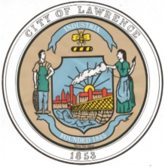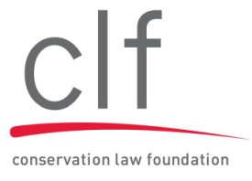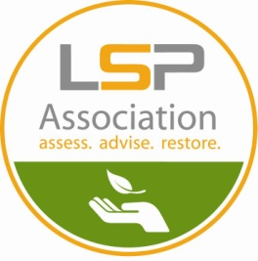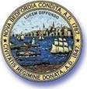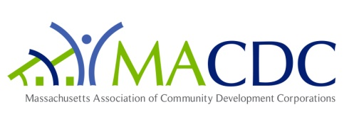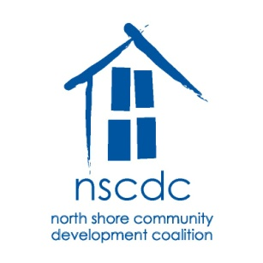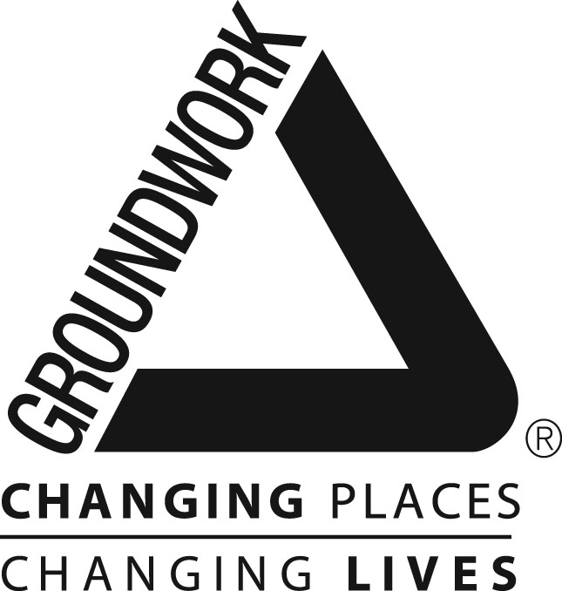[](http://www.environmentalleague.org/)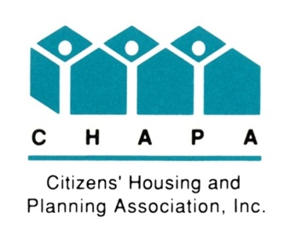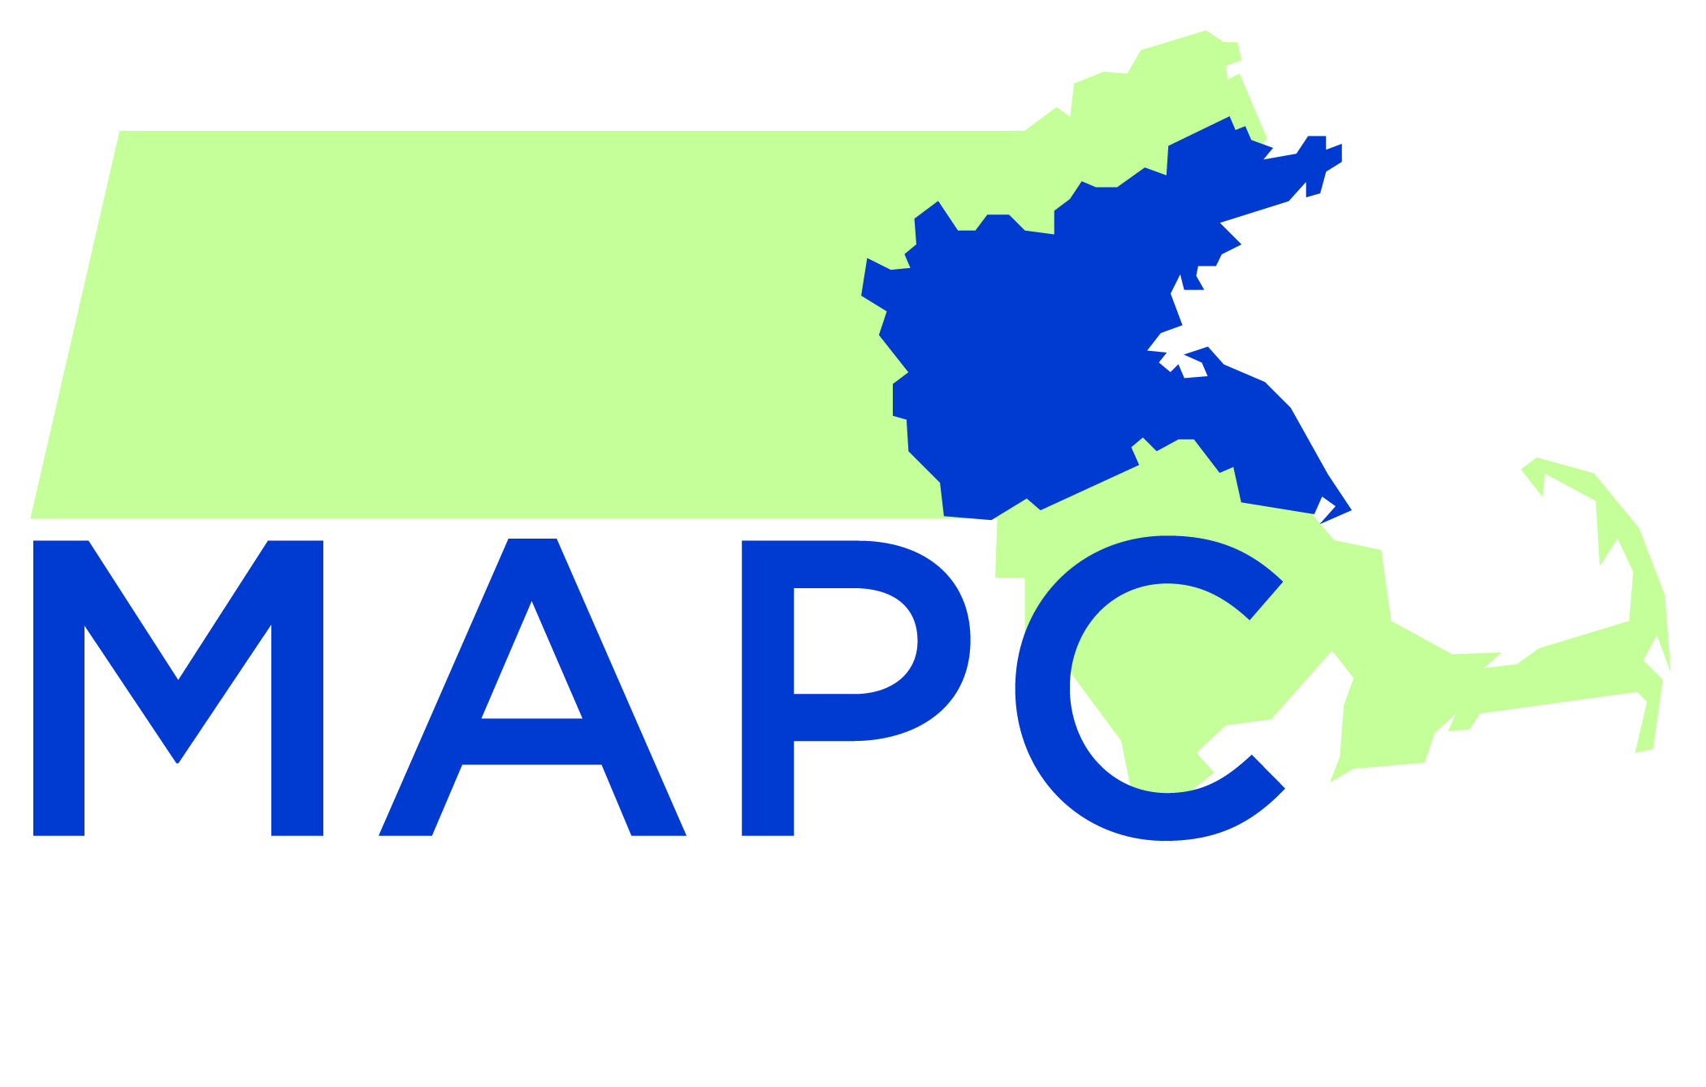

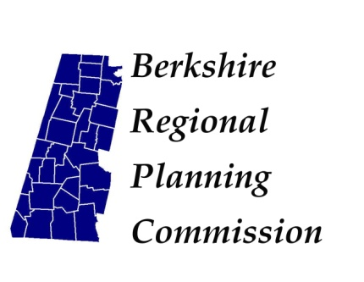Westmass logo-en.JPG

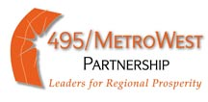



The Honorable Deval Patrick

Office of the Governor

State House, Room 105

Boston, MA 02133

The Honorable Therese Murray

President of the Senate

State House, Room 322

Boston, MA 02133

The Honorable Robert DeLeo

Speaker of the House

State House, Room 356

Boston, MA 02133

Dear Governor Patrick, Senate President Murray, and Speaker DeLeo:

We are writing today to express our support for the swift recapitalization of the Brownfields Redevelopment Fund, which has provided a vital source of revenue for development projects across the Commonwealth. Since its inception in 1998, the Fund has invested over $78 million through more than 630 individual awards on brownfields sites to support both housing and commercial development. In the last six years, projects financed by the Fund have created over 2600 jobs and over 4000 housing units.

The Brownfields Redevelopment Fund is critically important as more cities and towns across the Commonwealth look to underutilized or abandoned parcels as potential locations for development. As administered by MassDevelopment, the program provides financial assistance for both site assessment before a project is started and financing for the project itself. MassDevelopment has been transparent with how the Fund has operated and has provided valuable annual reports detailing the positive impact that these projects have had on cities and towns across the Commonwealth.

Due to increased utilization of the fund, it has been expended more quickly than was anticipated, leaving it fully depleted as of June 2013. Projects that were seeking assistance from the fund and were in the pipeline for that assistance are on hold. This recapitalization is vital to enable projects currently waiting for funding to move forward and to allow the fund to have a continued beneficial impact on cities and towns across Massachusetts.

We hope that you will join us in support of this effort. To discuss further, please contact Andre Leroux, Executive Director of the MA Smart Growth Alliance at 617-251-3861, or Rachel Heller, Policy Director of CHAPA at 617-742-0820 x103.

Sincerely,

495/MetroWest Partnership

AIA Massachusetts

Berkshire Regional Planning Commission

Citizens’ Housing and Planning Association

Conservation Law Foundation

Dorchester Bay Economic Development Corporation

Environmental League of Massachusetts

Groundwork Lawrence

LSP Association

Mass Audubon

Massachusetts Business Roundtable

Massachusetts Smart Growth Alliance

Mayor Jon Mitchell, City of New Bedford

Mayor Dan Rivera, City of Lawrence

Metropolitan Area Planning Council

Metropolitan Mayors Coalition

Massachusetts Association of Community Development Corporations

Massachusetts Association of Regional Planning Agencies

Mission Hill Neighborhood Housing Services

NAIOP – Commercial Real Estate Development Association – Massachusetts

North Shore Community Development Corporation

Westmass Area Development Corporation

Worcester Business Development Corporation